System Security: Lab Manual

MS Cyber Security

ITU Lahore



Submitted to: Muhammad Shehryar Raza

Submitted By: Eisha Nawaz

Roll No: MSCS22007

Lab 11: Hardware Root of Trust with TPM 2.0
Duration: 2 Hours
Mode: Group-based
Tools:
- Linux VM with virtual TPM
- tpm2-tools

1. Learning Objectives
Students will:
- Understand hardware root of trust
- Use TPM PCRs
- Seal/unseal secrets based on system state
- Observe how integrity violations block access

2. Scenario Description
A system must protect a cryptographic key such that it is only accessible if:
- Boot state is unchanged
- System integrity is intact

3. Group Roles
- System Owner: Performs sealing
- Attacker: Modifies system state
- Auditor: Observes TPM behavior

4. Environment Setup (20 minutes)

Install tools:
sudo apt install tpm2-tools -y
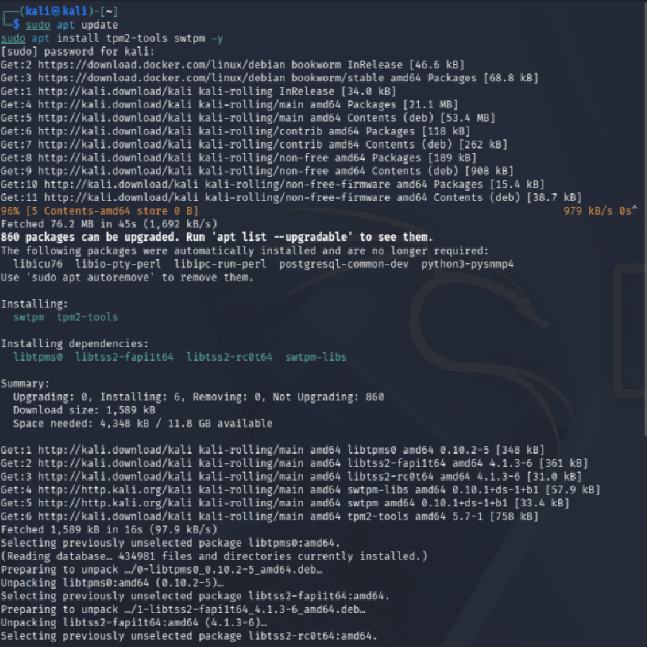

Create and Start a Virtual TPM (swtpm)
- Create directory for TPM state
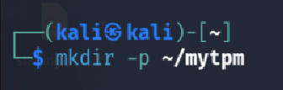

- Initialize the virtual TPM
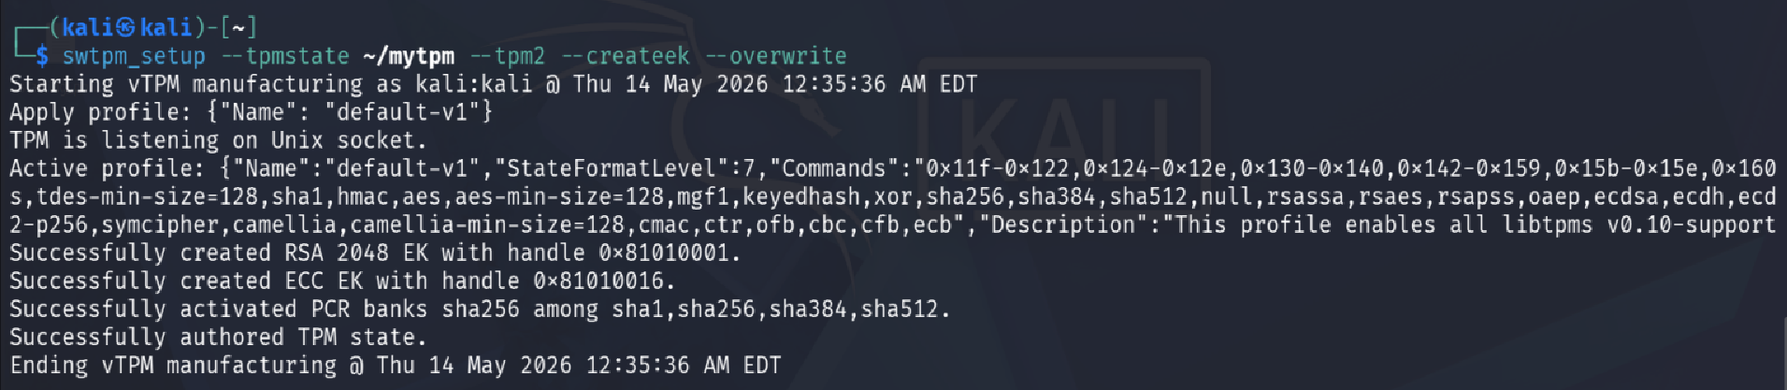
- Start Virtual TPM
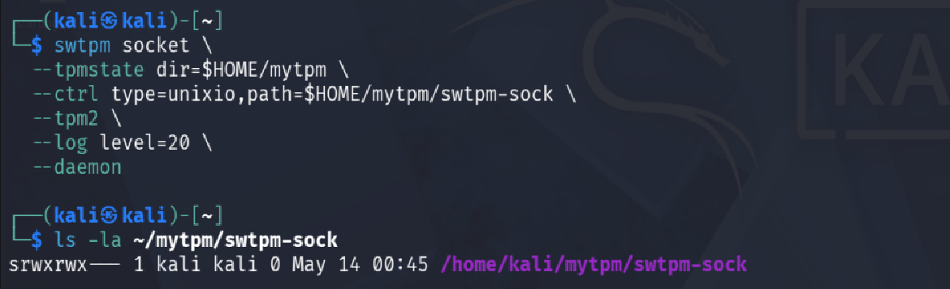
Test If TPM started

- Export and start TPM
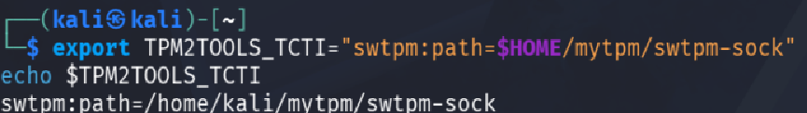

Verify TPM:
tpm2_getcap properties-fixed
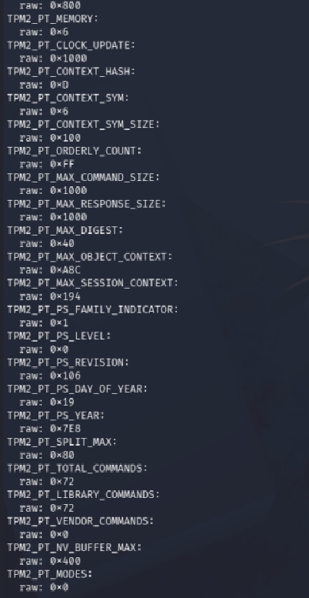
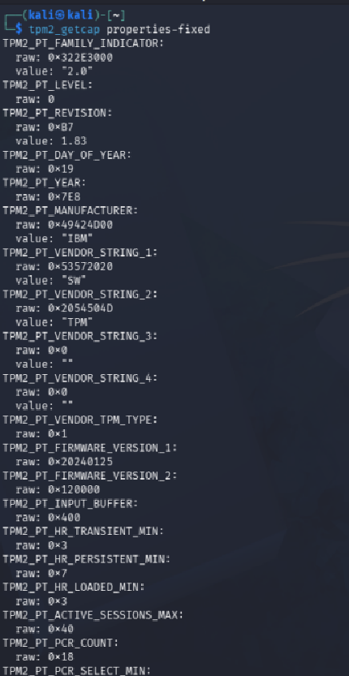

5. Step-by-Step Tasks

Task 1: Read PCR Values
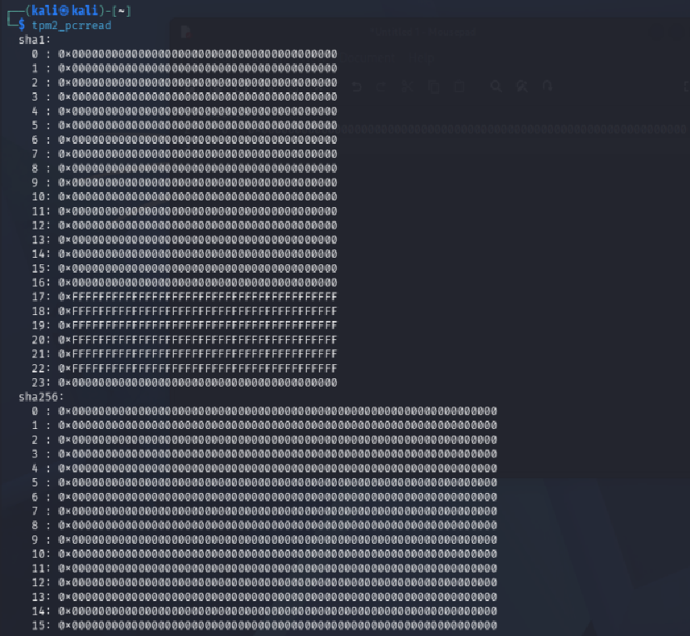

Run:
tpm2_pcrread sha256:0,2,4
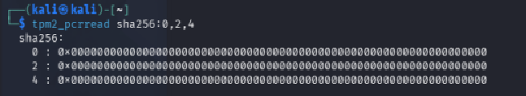
Document initial values.

Extend PCR 4 (simulate a boot measurement)
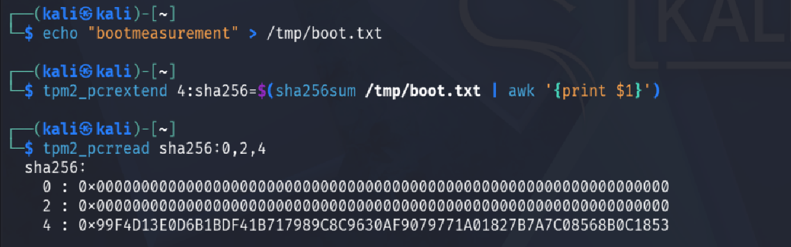
Read PCRs again to see the change
Extend PCR 4 with this value
Create a test measurement value

Save the Baseline
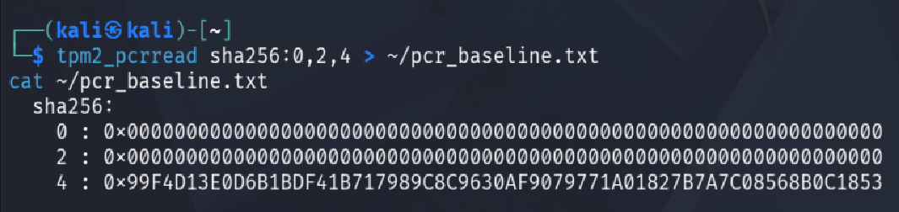

Task 2: Seal a Secret (20 minutes)

Create Primary Key
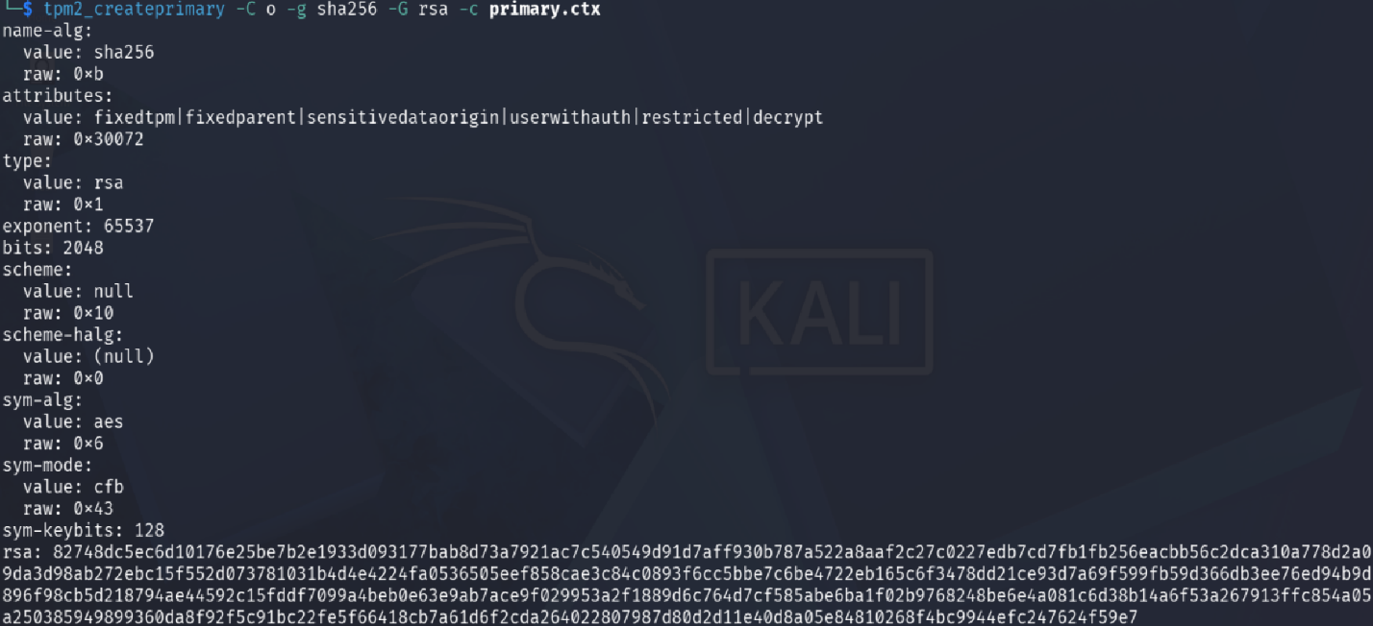

Create secret:
echo "TOP_SECRET_KEY" > secret.txt



Seal:
- tpm2_createpolicy --policy-pcr -l sha256:0,2,4 -L policy.dat
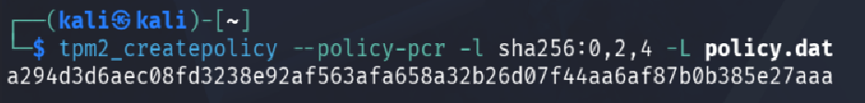
- Verify Policy was created
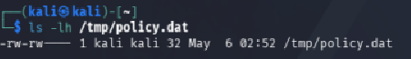

- tpm2_create -C o -u key.pub -r key.priv -L policy.dat
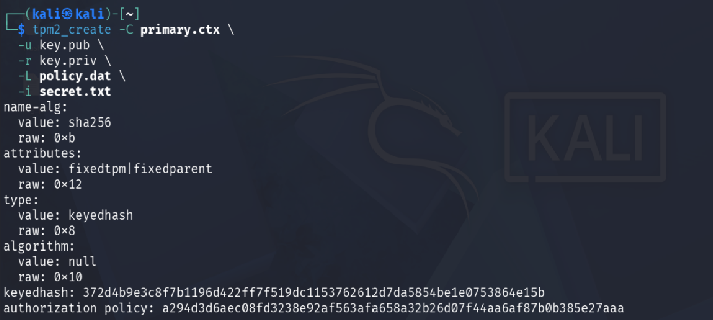

Confirmed Both Parts Exists:
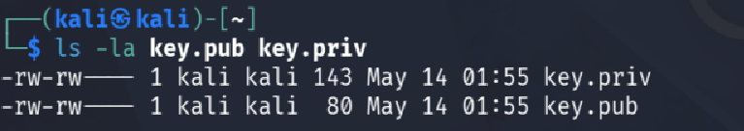
- Load the Sealed Object
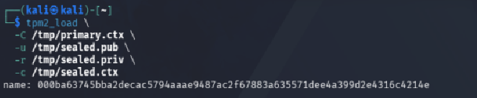

Task 3: Unseal Secret

Start an Authorization Session


Satisfy the PCR Policy
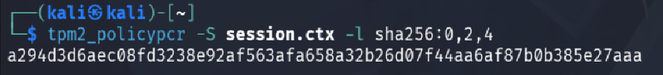

Unseal
tpm2_unseal -c key.ctx

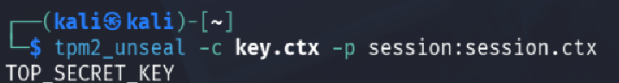

Flush the session


Task 4: Tamper System State

Change boot state (simulated):
sudo modprobe dummy
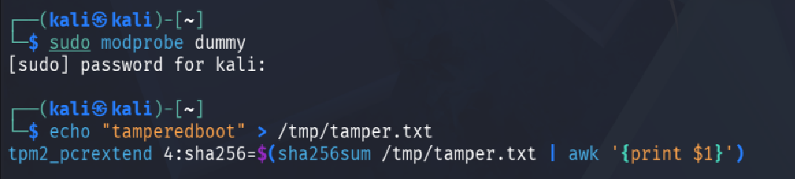
Extend PCR 4 again to simulate tampered boot state

Re-read PCRs
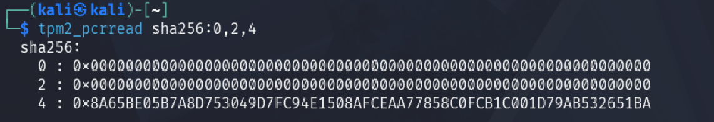

Unsealing Again
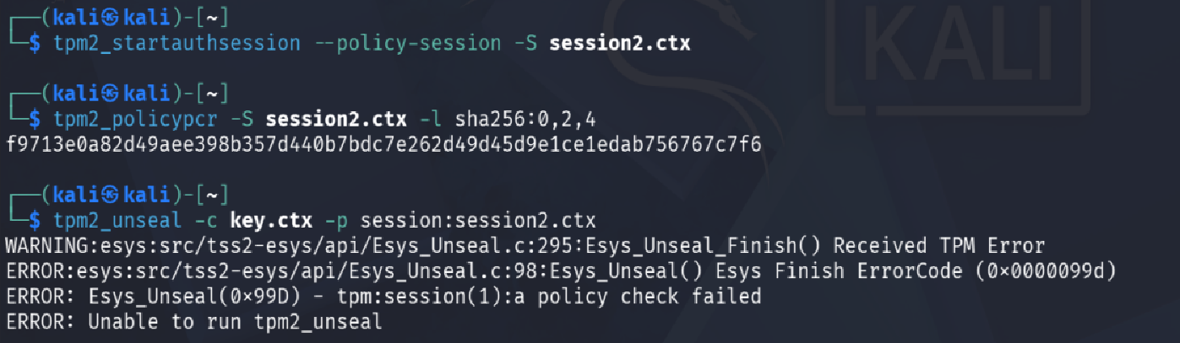

Task 5: Reflection

Why TPM prevents offline attacks
The secret is stored in the TPM hardware and locked to particular PCR values. If the attacker is able to steal the disk, it is impossible to divulge the secret unless they had the exact same TPM hardware with the same PCR state. There is no key in plain text outside the TPM.

How secure boot complements TPM

Secure Boot ensures only signed, trusted bootloaders and kernels run. TPM records each boot step into PCRs. Together they create a chain of trust, if anything in the boot process changes, PCRs change, and TPM-sealed secrets become inaccessible.

Real-world uses (disk encryption, attestation)
Use Case | How TPM Helps
Disk Encryption (BitLocker/LUKS) | Seals disk key to PCRs; auto-unlocks only if boot is untampered
Remote Attestation | Proves to a remote server that the system is in a known-good state
SSH Key Protection | Private keys sealed in TPM, never exposed to OS
Code Signing | TPM stores signing keys that never leave the chip

